

Contact: Jason Morton

CZ-USA
(913) 321-1811
Fax: (913) 321-2251
jason@cz-usa.com

For Immediate Release

Kansas City, KS – 1 November 2010

Dan Wesson Reintroduces the 715 Revolver, .357 Magnum

The 715 is now as it was before, designed and built to be the most accurate, rugged and versatile revolver available. Barrel assemblies and grips are easily swapped by the shooter with those designed for model 15-2 and later. The HV6 barrel is a 6” barrel with a new heavy vent shroud profile which is being introduced exclusively on the new Dan Wesson 715 revolver.

The relatively short and light double action trigger cycle with crisp target like single action trigger pull made the Dan Wesson revolvers a favorite among competitors and hunters alike. A tradition that still continues.

The Dan Wesson revolver design improved on the accuracy and service life of the traditional double action revolver design in a few ways. The tensioned barrel of the DW interchangeable bbl system enhances accuracy as does the forward located crane latch. The crane latch is located at the front of the cylinder. This forward lock coupled with a rear ball detent helps to ensure proper cylinder/barrel alignment during firing more than the rear locking designs of other revolvers. While the tensioned barrel definitely improves accuracy above other revolvers, the consistent cylinder/barrel alignment probably contributes more to the superior accuracy of the 715 than any other design feature. The unique clockwise rotating cylinder turns into the frame reducing stress on the crane. Keeping the alignment tight extends the service life of the revolver and as a bonus preserves accuracy longer than other designs as well. In addition the DW revolver is built on a robust frame design to handle the heaviest of factory loads.

Each Revolver is shipped in a custom Dan Wesson hard case. Patterned after the ever popular Pistol Pack, each case has compartments for three additional barrel assemblies and factory supplied barrel wrench kit.

- Dan Wesson interchangeable bbl system = versatility and accuracy
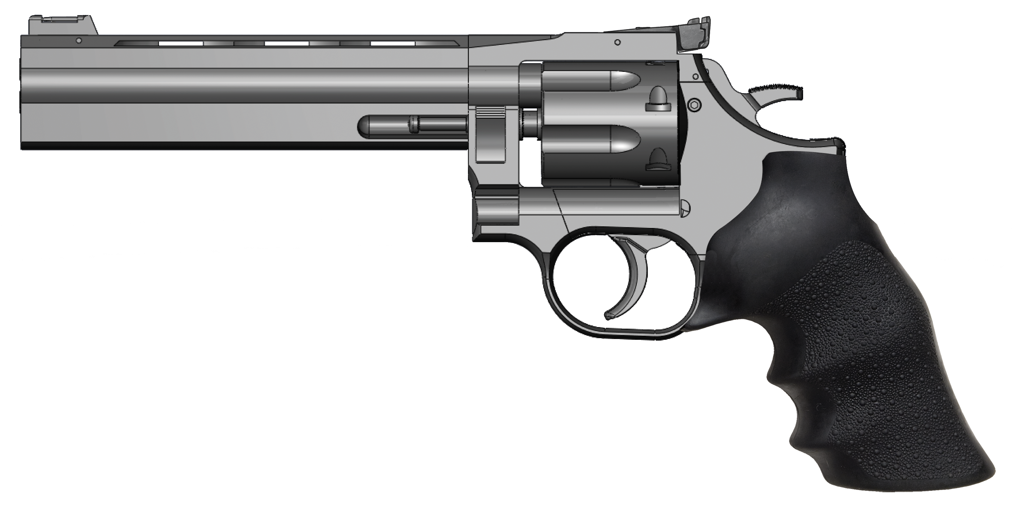
- Adjustable target rear sight
- 6” heavy barrel with ventilated rib
- Finger grooved Hogue rubber grip
- Transfer bar safety
- 416 stainless steel construction
- Front crane latch and rear ball detent
- Includes bbl wrench kit
- 46 oz

Accessories and barrel assemblies from 2.5” to 10” are easily swapped by the shooter and are available from CZ-USA and Dan Wesson.

Item # and Suggested Retail Price:
#01932 DAN WESSON REVOLVER 715 cal. 357 Magnum w/ HV6 barrel $ TBA

P.O. Box 171073, Kansas City, Kansas 66117-0073 t: 800-955-4486 p:913-321-1811 f:913-321-1811 e-mail: info@cz-usa.com

